**Peripheral Devices:**

The devices connected to a computer to entend the computer’s functionality are called peripheral devices.

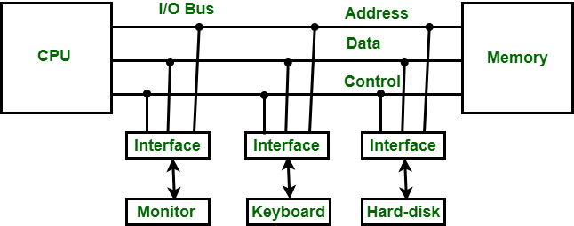Different types and varieities of peripheral devices are available. They have different mode of operation, data transfer rate of peripherals is often much slower than memory. Different peripheral devices use different data formats and word length. They also work differently. Some are electromagnatic, electromechanical, piezoelectric, etc. They need conversion of data too.

**Function of I/O interface:**

* Data conversion
* Synchronization
* Device selection

**I/O Interface:**

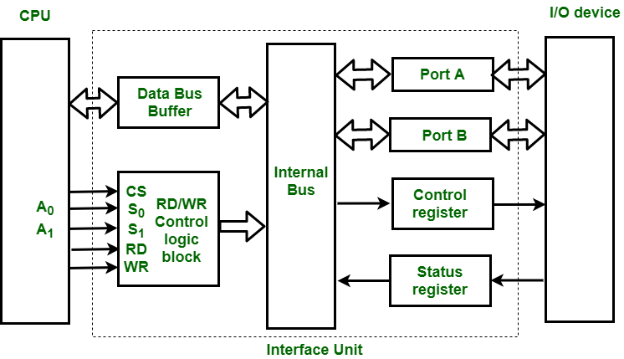

**Isolated I/O vs Memory Mapped I/O:**

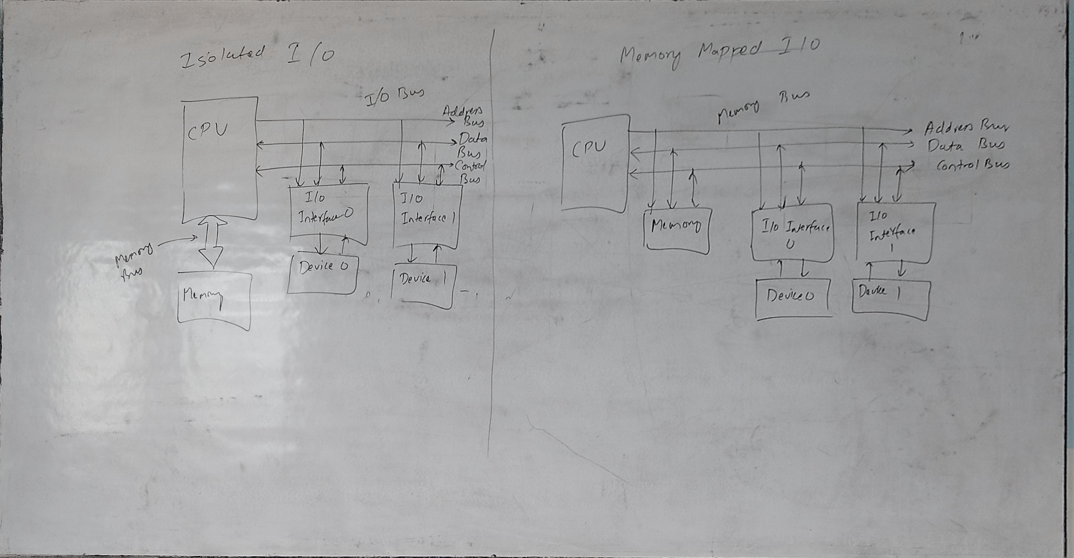

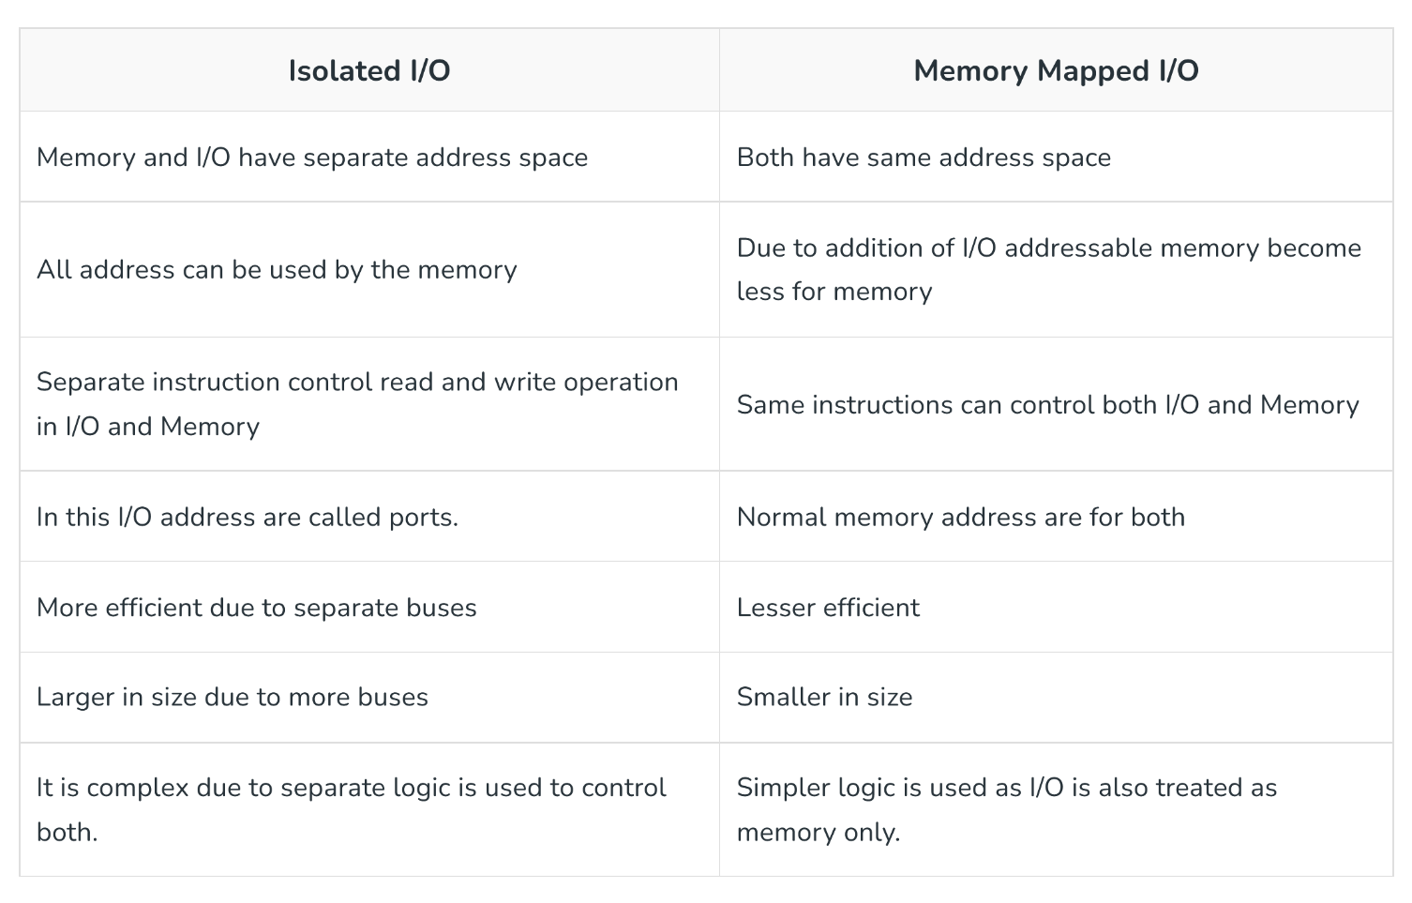

**Mode of data Transfer:**

1. Programmed I/O
2. Interrupt Driven I/O
3. DMA

Programmed/Polled I/O:

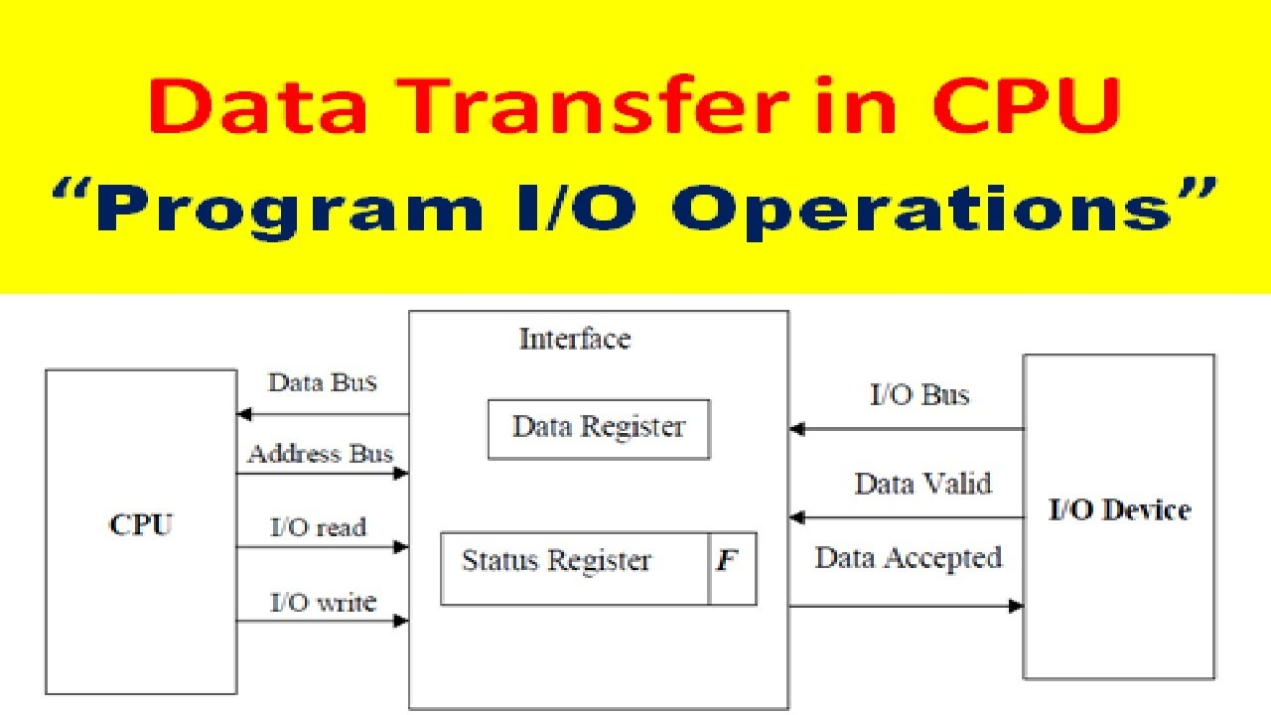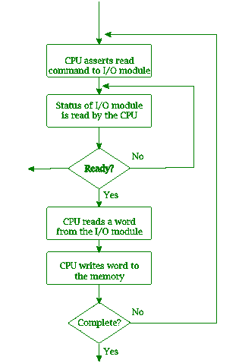

Disadvantages:

1. CPU will have to wait in loop until device is ready to send data.
2. This causes other programs to wait.
3. This is mostly used in simple CPU.

Interupt Driven I/O:

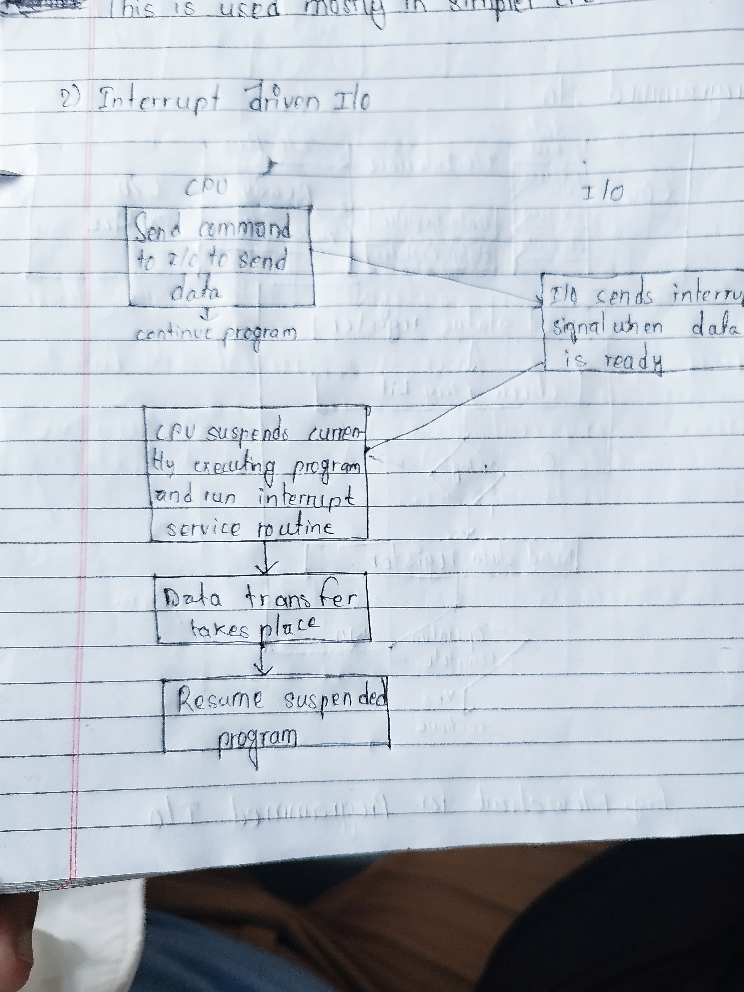

Interupt priority:

* Hardware
  + Daisy Chain
  + Parallel Priority Interupt

**Daisy Chain:**

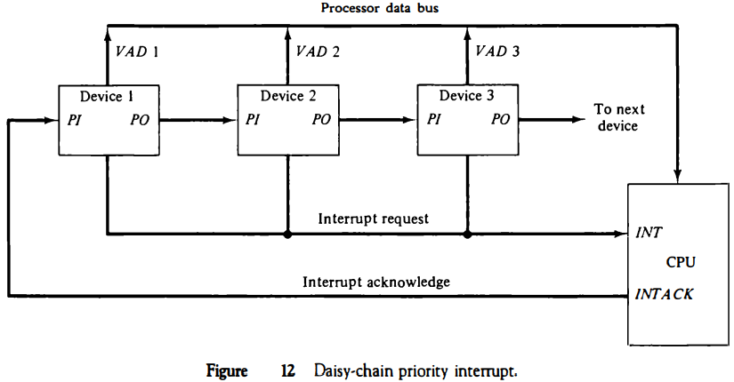

1.Dev2 sends interrupt to cpu via INTR pin.

2.CPU reverts INTA signal to devices.

INTA acknowledge signal is transferred to device in daisy chain manner.

3.First device 1(Dev1) gets INTA signal. Since it doesnot send interupt signal it will transfer the signal to device 2(Dev2).

4.When device 2 gets the INTA signal it will now send vector address through data bus to CPU.

5.CPU after receiving vector address runs the interrupt routine at that address.

**Parallel Priority Interupt:**

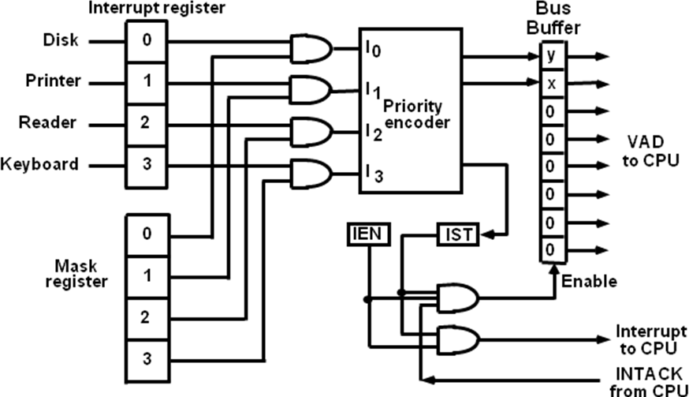

**Priority encoder encoding:**

|  |  |  |  |  |  |  |  |
| --- | --- | --- | --- | --- | --- | --- | --- |
| Input | | | | Output | | | |
| I0 | I1 | I2 | I3 | | x | y | IST |
| 1 | x | x | x | | 0 | 0 | 1 |
| 0 | 1 | x | x | | 0 | 1 | 1 |
| 0 | 0 | 1 | x | | 1 | 0 | 1 |
| 0 | 0 | 0 | 1 | | 1 | 1 | 1 |
| 0 | 0 | 0 | 0 | | - | - | 0 |

**Polling:**

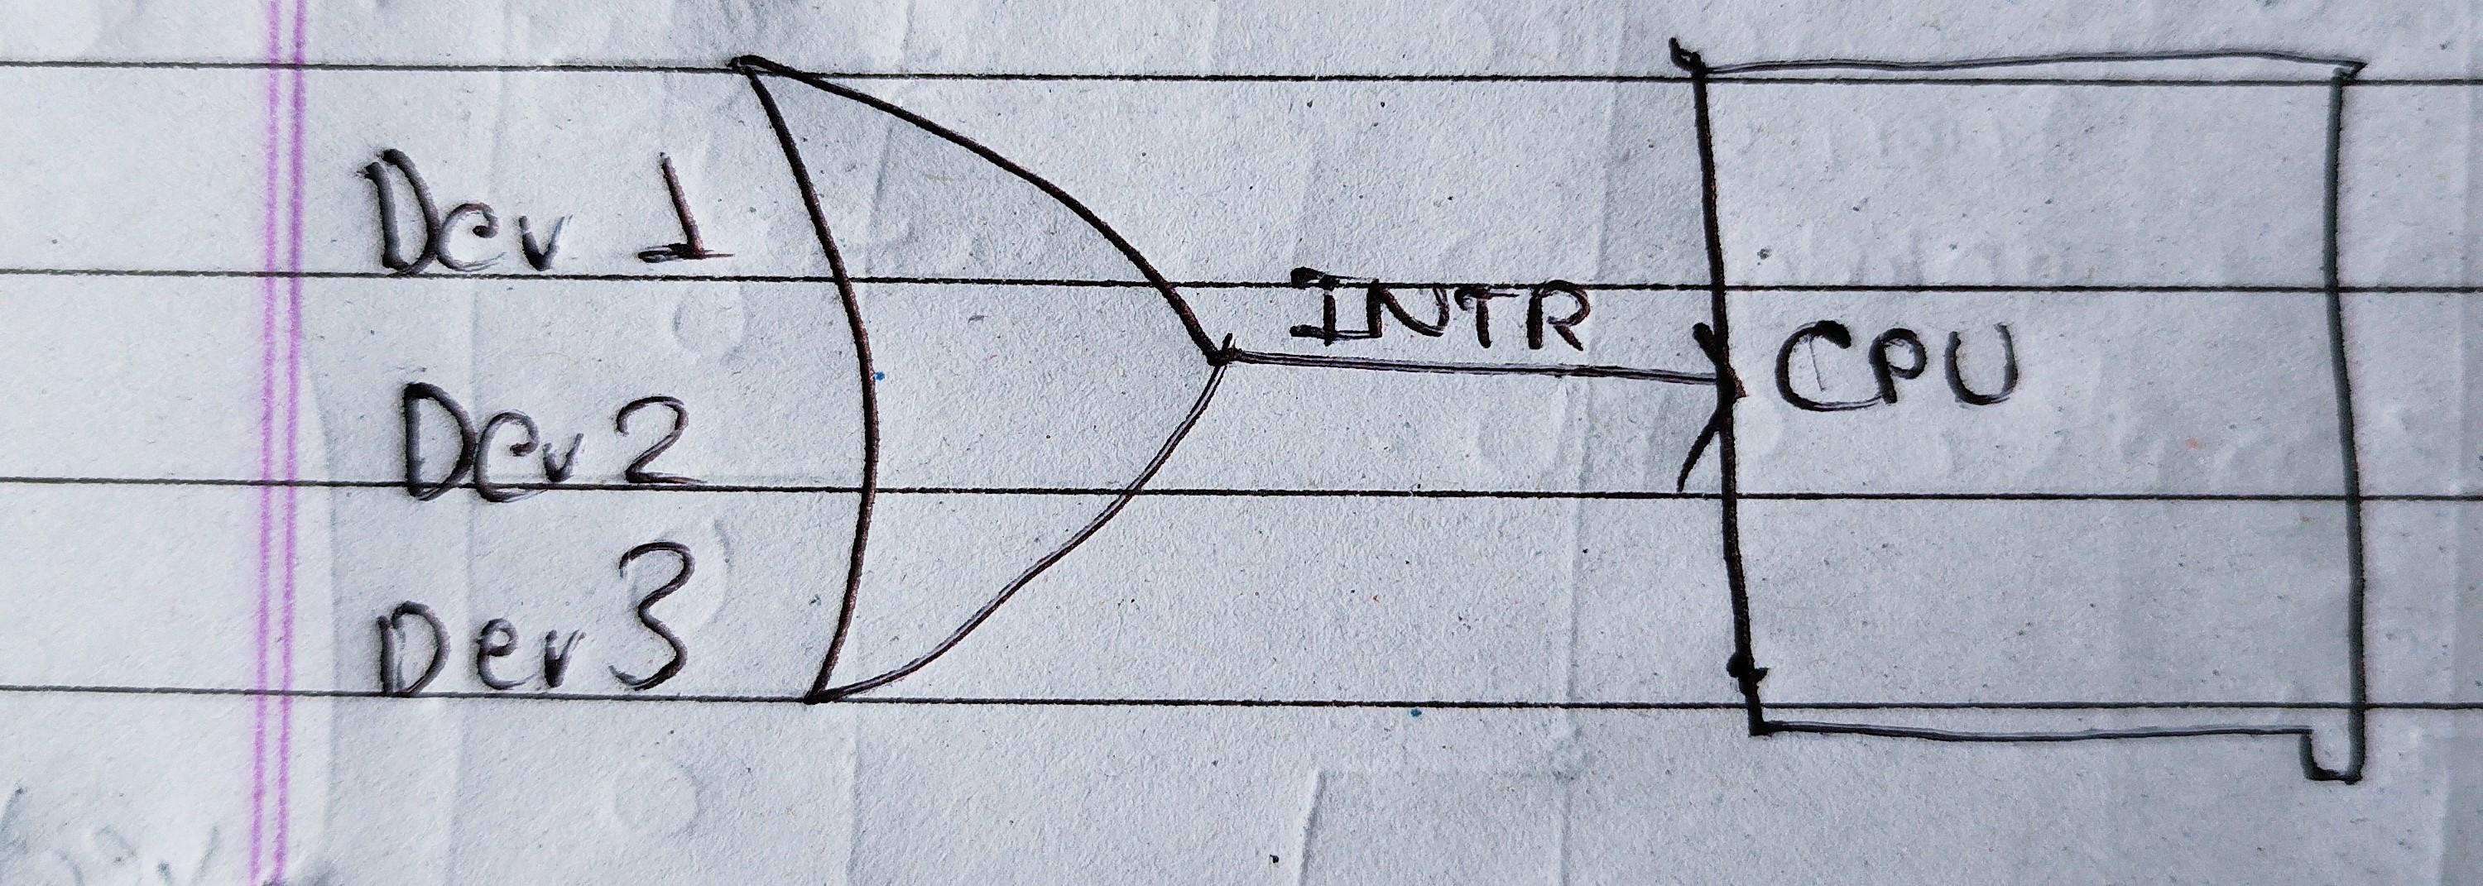If CPU gets interupt signal from the devices, then CPU will start polling each devices if the have sent interupt or not (in interupt service routine).

**DMA:**

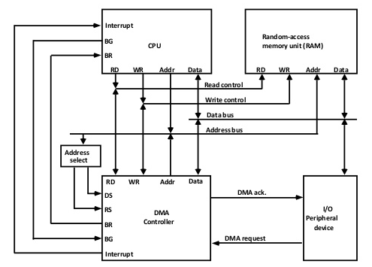

DMA is an input Protocol which allows the I/O to directly access the system memory without wasting CPU cycles. It requires a seperate controller called DMA controller which bridges the gap between I/O and Memory.

**IOP:**

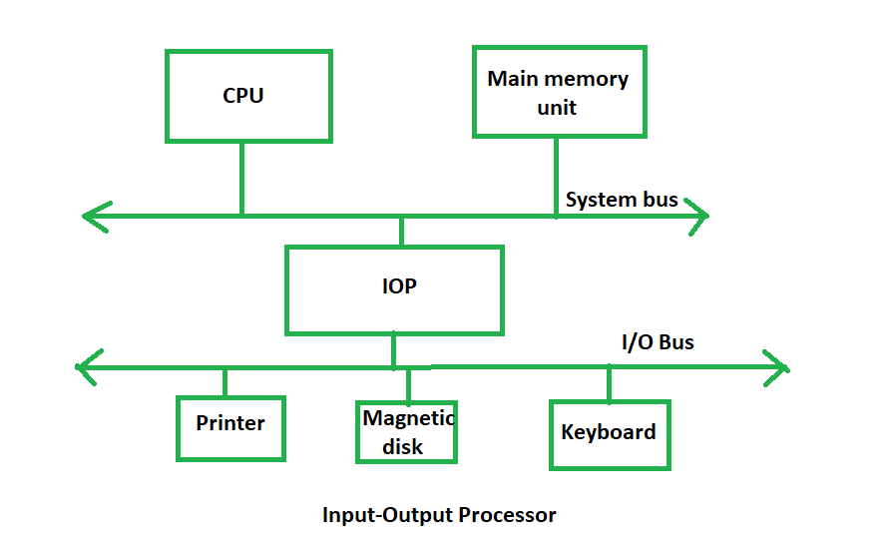

IOP is a processor/controller which handles I/O operations. It is more equipped with facilities than those are available in typical DMA controller. The IOP can fetch and execute its own instructions that are specifically designed to characterize I/O transfers. In addition to the I/O – related tasks, it can perform other processing tasks like arithmetic, logic, branching and code translation. The main memory unit takes the pivotal role. It communicates with processor by the means of DMA.